|  |  |  |  |  |  |  |  |  |  |  |
| --- | --- | --- | --- | --- | --- | --- | --- | --- | --- | --- |
| **NFC Institute of Engineering & Fertilizer Research Faisalabad**  **Department of Mechanical Engineering** | | | | | | | | | | |
| **Course Name: Finite Element Analysis** | | | | | | | | | | |
| **Examination** | | **Course Code** | **Session** | **Semester** | | **Total Marks** | | **Maximum Time** | | |
| **CEP** | | **ME-451** | **2018** | **7th** | | **20** | | **1 week** | | |
| **Q. #** | **Statement** | | | **CLO** | **PLO** | | **Bloom Taxonomy** | | **Marks** | **KPI** |
| **Q. 1** | | | | **2** | **5** | | **C5** | | **10** | **50%** |
| **Evaluate the solution by using MATLAB code for given problem. Evaluate nodal dispacements, elemental forces and reaction forces** | | | | | | | | | | |

A rigid plane frame is defined here as a series of beam elements rigidly connected to each other; that is, the original angles made between elements at their joints remain unchanged after the deformation due to applied loads or applied displacements.

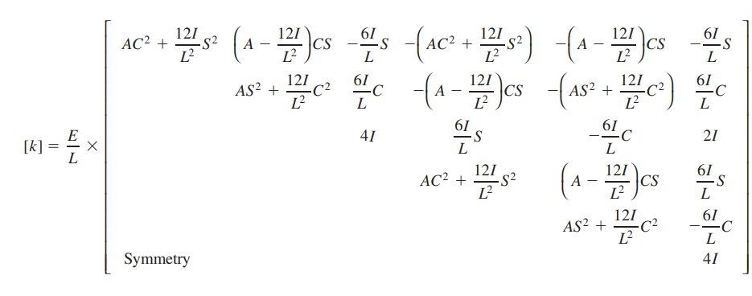K matrix for rigid plane frame

T matrix for Rigid plane frame

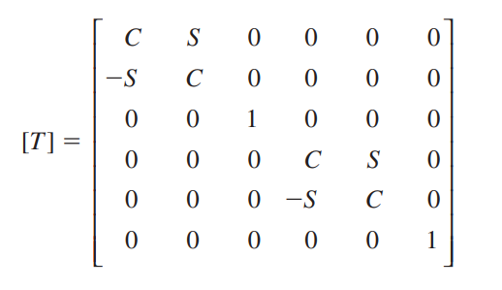

## MATLAB Editor Code for Above Question

EE=210e9; %Modulus of elasticity

AA=80e-3; %Area of cross section for all elements m2

II=1.2e-4; %Area moment of inertia for all elements m4

LL1=3; %Length of element 1 m

LL2=6; %Length of element 2 m

Theta_1=0; %Angle in degree

Theta_2=90; %Angle in degree

F1y=-1e5; %Applied load(down at node 1)

d3x=0; %x-displacement 3 is zero

d3y=0; %y-displacement at node 3 is zero

Theta_3=0; %angular displacement at node 3 is zero

C1=cosd(Theta_1); %Cosine of angle between local x and global x for element 1

S1=sind(Theta_1); %Sine of angle between local x and global x for element 1

C2=cosd(Theta_2); %Cosine of angle between local x and global x for element 2

S2=sind(Theta_2); %Sine of angle between local x and global x for element 2

M1=(AA*C1^2)+((12*II*S1^2)/LL1^2)

M2=(AA-((12*II)/LL1^2))*C1*S1

M3=(AA*S1^2)+((12*II*C1^2)/LL1^2)

ISL=6*II*S1/LL1

ICL=6*II*C1/LL1

K1=(EE/LL1)*[M1 M2 -ISL -M1 -M2 -ISL;M2 M3 ICL -M2 -M3 ICL;-ISL ICL 4*II ISL -ICL 2*II;

-M1 -M2 ISL M1 M2 ISL;-M2 -M3 -ICL M2 M3 -ICL;-ISL ICL 2*II ISL -ICL 4*II]

K1a=K1

K1a(9,9)=0

M12=(AA*C2^2)+((12*II*S2^2)/LL2^2)

M22=(AA-((12*II)/LL2^2))*(C2*S2)

M32=(AA*S2^2)+((12*II*C2^2)/LL2^2)

ISL2=6*II*S2/LL2

ICL2=(6*II*C2)/LL2

K2=(EE/LL2)*[M12 -M22 ISL2 -M12 M22 ISL2;-M22 M32 ICL2 M22 -M32 ICL2;ISL2 ICL2 4*II -ISL2 -ICL2 2*II;

-M12 M22 -ISL2 M12 -M22 -ISL2;M22 -M32 -ICL2 -M22 M32 -ICL2;ISL2 ICL2 2*II -ISL2 -ICL2 4*II]

K2a=zeros(size(K1a))

K2a(4:end,4:end)=K2

K=K1a+K2a

Ksub=K([1,2,3,4,5,6],[1,2,3,4,5,6])

Fy=-10000

Fpart=[0;Fy;0;0;0;0] %e partitioned vector of applied loads

[D]=linsolve(Ksub,Fpart)

syms U1 V1 Ph1 U2 V2 Ph2

U1=D(1,1)

V1=D(2,1)

Ph1=D(3,1)

U2=D(4,1)

V2=D(5,1)

Ph2=D(6,1)

U3=0

V3=0

Ph3=0

format LongE

D1=[U1;V1;Ph1;U2;V2;Ph2;U3;V3;Ph3]

FM=K*D1

**%For element 1**

AEL=AA*EE/LL1

EIL=2*EE*II/LL1

EIL1=4*EE*II/LL1

EIL2=6*EE*II/LL1^2

EIL3=12*EE*II/LL1^3

Klocal1=[AEL 0 0 -AEL 0 0;0 EIL3 EIL2 0 -EIL3 EIL2;0 EIL2 EIL1 0 -EIL2 EIL;

-AEL 0 0 AEL 0 0;0 -EIL3 -EIL2 0 EIL3 -EIL2;0 EIL2 EIL 0 -EIL2 EIL1]

TCS1=[C1 S1 0 0 0 0;-S1 C1 0 0 0 0;0 0 1 0 0 0;0 0 0 C1 S1 0;0 0 0 -S1 C1 0;0 0 0 0 0 1]

F1=Klocal1*TCS1*D

**%For element 2**

AEL2=AA*EE/LL2

EIL2=2*EE*II/LL2

EIL12=4*EE*II/LL2

EIL22=6*EE*II/LL2^2

EIL32=12*EE*II/LL2^3

Klocal2=[AEL2 0 0 -AEL2 0 0;0 EIL32 EIL22 0 -EIL32 EIL22;0 EIL22 EIL12 0 -EIL22 EIL2;

-AEL2 0 0 AEL2 0 0;0 -EIL32 -EIL22 0 EIL32 -EIL22;0 EIL22 EIL2 0 -EIL22 EIL12]

TCS2=[C2 -S2 0 0 0 0;S2 C2 0 0 0 0;0 0 1 0 0 0;0 0 0 C2 -S2 0;0 0 0 S2 C2 0;0 0 0 0 0 1]

F2=Klocal2*TCS2*[U2;V2;Ph2;U3;V3;Ph3]

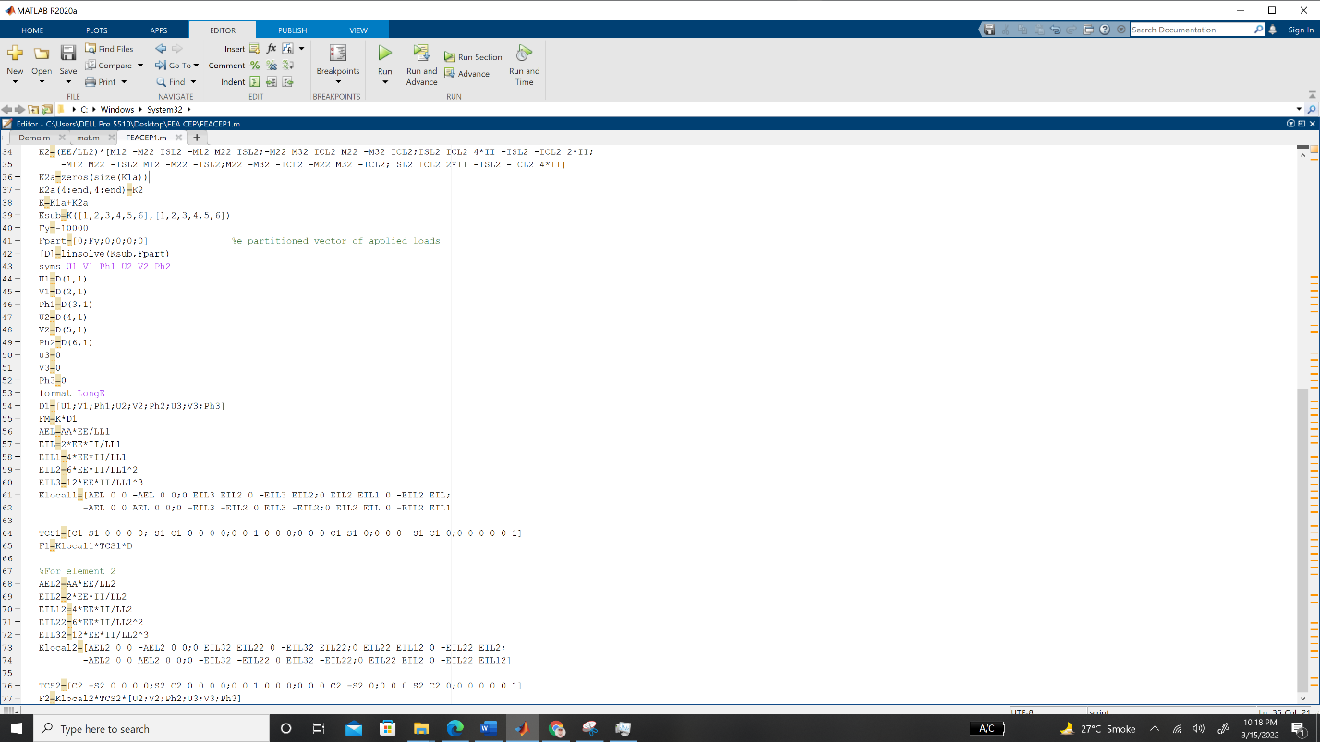

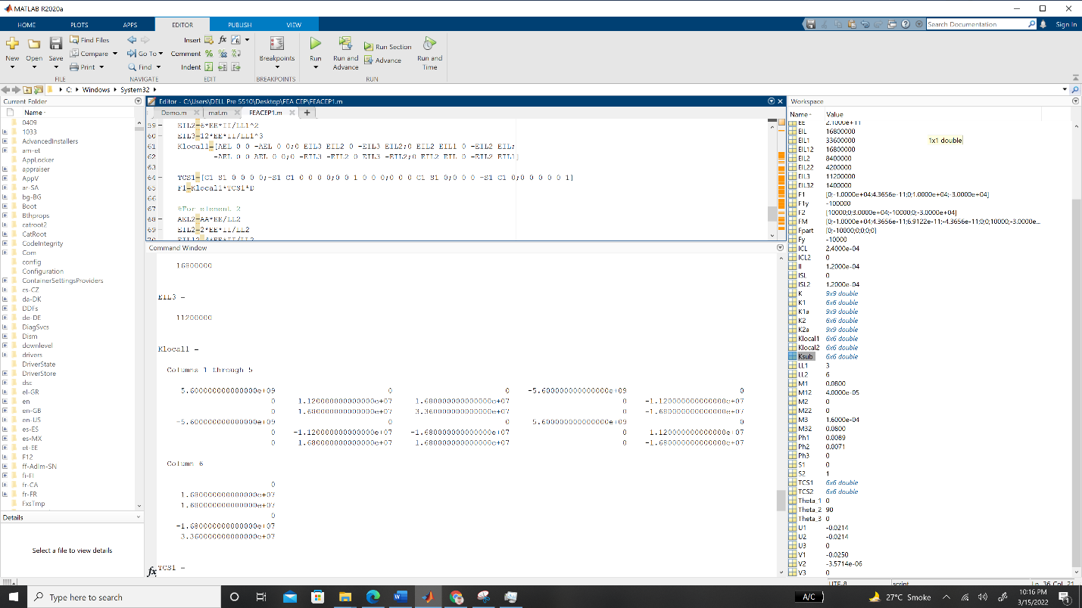

## Values Saved by MATLAB Workspace

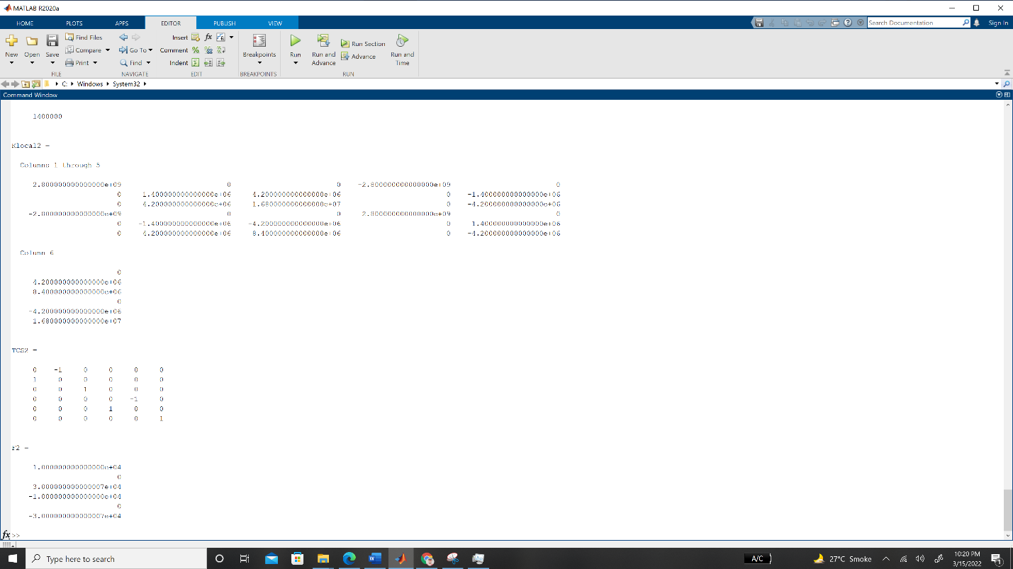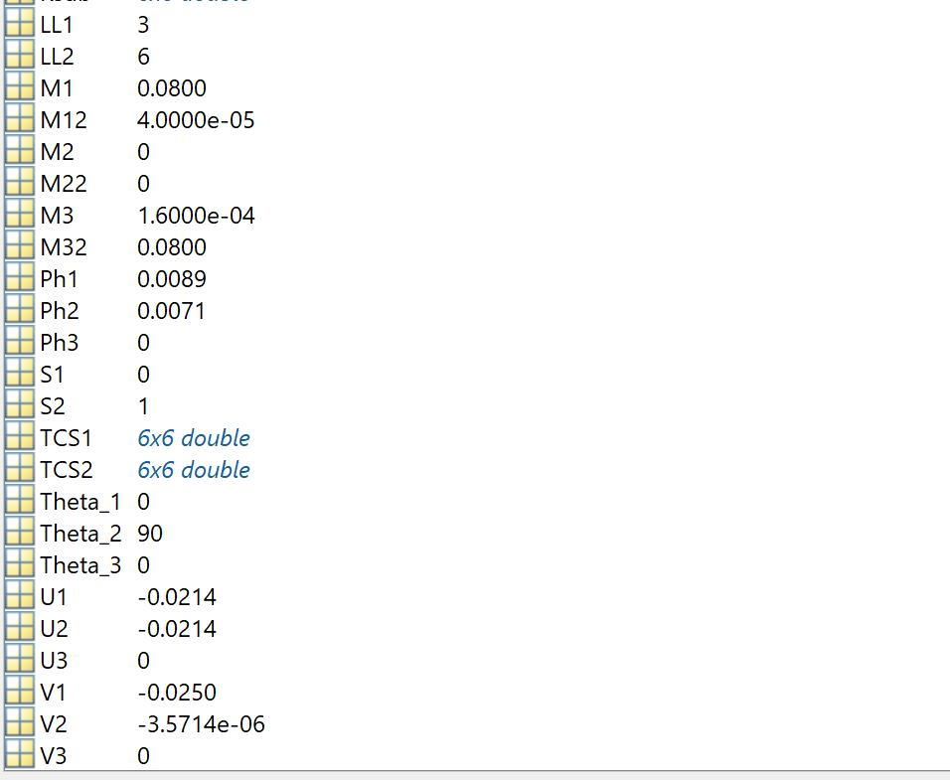

## Solution in Command Window

**M1 =**

8.000000000000000e-02

**M2 =**

0

**M3 =**

1.600000000000000e-04

**ISL =**

0

**ICL =**

2.400000000000000e-04

**K1 =**

**Columns 1 through 5**

5.600000000000000e+09 0 0 -5.600000000000000e+09 0

0 1.120000000000000e+07 1.680000000000000e+07 0 -1.120000000000000e+07

0 1.680000000000000e+07 3.360000000000000e+07 0 -1.680000000000000e+07

-5.600000000000000e+09 0 0 5.600000000000000e+09 0

0 -1.120000000000000e+07 -1.680000000000000e+07 0 1.120000000000000e+07

0 1.680000000000000e+07 1.680000000000000e+07 0 -1.680000000000000e+07

**Column 6**

0

1.680000000000000e+07

1.680000000000000e+07

0

-1.680000000000000e+07

3.360000000000000e+07

**K1a =**

**Columns 1 through 5**

5.600000000000000e+09 0 0 -5.600000000000000e+09 0

0 1.120000000000000e+07 1.680000000000000e+07 0 -1.120000000000000e+07

0 1.680000000000000e+07 3.360000000000000e+07 0 -1.680000000000000e+07

-5.600000000000000e+09 0 0 5.600000000000000e+09 0

0 -1.120000000000000e+07 -1.680000000000000e+07 0 1.120000000000000e+07

0 1.680000000000000e+07 1.680000000000000e+07 0 -1.680000000000000e+07

**Column 6**

0

1.680000000000000e+07

1.680000000000000e+07

0

-1.680000000000000e+07

3.360000000000000e+07

**K1a =**

**Columns 1 through 5**

5.600000000000000e+09 0 0 -5.600000000000000e+09 0

0 1.120000000000000e+07 1.680000000000000e+07 0 -1.120000000000000e+07

0 1.680000000000000e+07 3.360000000000000e+07 0 -1.680000000000000e+07

-5.600000000000000e+09 0 0 5.600000000000000e+09 0

0 -1.120000000000000e+07 -1.680000000000000e+07 0 1.120000000000000e+07

0 1.680000000000000e+07 1.680000000000000e+07 0 -1.680000000000000e+07

0 0 0 0 0

0 0 0 0 0

0 0 0 0 0

**Columns 6 through 9**

0 0 0 0

1.680000000000000e+07 0 0 0

1.680000000000000e+07 0 0 0

0 0 0 0

-1.680000000000000e+07 0 0 0

3.360000000000000e+07 0 0 0

0 0 0 0

0 0 0 0

0 0 0 0

**M12 =**

4.000000000000000e-05

**M22 =**

0

**M32 =**

8.000000000000000e-02

**ISL2 =**

1.200000000000000e-04

**ICL2 =**

0

**K2 =**

**Columns 1 through 5**

1.400000000000000e+06 0 4.200000000000000e+06 -1.400000000000000e+06 0

0 2.800000000000000e+09 0 0 -2.800000000000000e+09

4.200000000000000e+06 0 1.680000000000000e+07 -4.200000000000000e+06 0

-1.400000000000000e+06 0 -4.200000000000000e+06 1.400000000000000e+06 0

0 -2.800000000000000e+09 0 0 2.800000000000000e+09

4.200000000000000e+06 0 8.400000000000000e+06 -4.200000000000000e+06 0

**Column 6**

4.200000000000000e+06

0

8.400000000000000e+06

-4.200000000000000e+06

0

1.680000000000000e+07

**K2a =**

0 0 0 0 0 0 0 0 0

0 0 0 0 0 0 0 0 0

0 0 0 0 0 0 0 0 0

0 0 0 0 0 0 0 0 0

0 0 0 0 0 0 0 0 0

0 0 0 0 0 0 0 0 0

0 0 0 0 0 0 0 0 0

0 0 0 0 0 0 0 0 0

0 0 0 0 0 0 0 0 0

**K2a =**

**Columns 1 through 5**

0 0 0 0 0

0 0 0 0 0

0 0 0 0 0

0 0 0 1.400000000000000e+06 0

0 0 0 0 2.800000000000000e+09

0 0 0 4.200000000000000e+06 0

0 0 0 -1.400000000000000e+06 0

0 0 0 0 -2.800000000000000e+09

0 0 0 4.200000000000000e+06 0

**Columns 6 through 9**

0 0 0 0

0 0 0 0

0 0 0 0

4.200000000000000e+06 -1.400000000000000e+06 0 4.200000000000000e+06

0 0 -2.800000000000000e+09 0

1.680000000000000e+07 -4.200000000000000e+06 0 8.400000000000000e+06

-4.200000000000000e+06 1.400000000000000e+06 0 -4.200000000000000e+06

0 0 2.800000000000000e+09 0

8.400000000000000e+06 -4.200000000000000e+06 0 1.680000000000000e+07

**K =**

**Columns 1 through 5**

5.600000000000000e+09 0 0 -5.600000000000000e+09 0

0 1.120000000000000e+07 1.680000000000000e+07 0 -1.120000000000000e+07

0 1.680000000000000e+07 3.360000000000000e+07 0 -1.680000000000000e+07

-5.600000000000000e+09 0 0 5.601400000000000e+09 0

0 -1.120000000000000e+07 -1.680000000000000e+07 0 2.811200000000000e+09

0 1.680000000000000e+07 1.680000000000000e+07 4.200000000000000e+06 -1.680000000000000e+07

0 0 0 -1.400000000000000e+06 0

0 0 0 0 -2.800000000000000e+09

0 0 0 4.200000000000000e+06 0

**Columns 6 through 9**

0 0 0 0

1.680000000000000e+07 0 0 0

1.680000000000000e+07 0 0 0

4.200000000000000e+06 -1.400000000000000e+06 0 4.200000000000000e+06

-1.680000000000000e+07 0 -2.800000000000000e+09 0

5.040000000000000e+07 -4.200000000000000e+06 0 8.400000000000000e+06

-4.200000000000000e+06 1.400000000000000e+06 0 -4.200000000000000e+06

0 0 2.800000000000000e+09 0

8.400000000000000e+06 -4.200000000000000e+06 0 1.680000000000000e+07

**Ksub =**

**Columns 1 through 5**

5.600000000000000e+09 0 0 -5.600000000000000e+09 0

0 1.120000000000000e+07 1.680000000000000e+07 0 -1.120000000000000e+07

0 1.680000000000000e+07 3.360000000000000e+07 0 -1.680000000000000e+07

-5.600000000000000e+09 0 0 5.601400000000000e+09 0

0 -1.120000000000000e+07 -1.680000000000000e+07 0 2.811200000000000e+09

0 1.680000000000000e+07 1.680000000000000e+07 4.200000000000000e+06 -1.680000000000000e+07

**Column 6**

0

1.680000000000000e+07

1.680000000000000e+07

4.200000000000000e+06

-1.680000000000000e+07

5.040000000000000e+07

**Fy =**

-10000

**Fpart =**

0

-10000

0

0

0

0

**D =**

**-**2.142857142857148e-02

-2.500357142857148e-02

8.928571428571449e-03

-2.142857142857148e-02

-3.571428571428571e-06

7.142857142857159e-03

**U1 =**

-2.142857142857148e-02

**V1 =**

-2.500357142857148e-02

**Ph1 =**

8.928571428571449e-03

**U2 =**

-2.142857142857148e-02

**V2 =**

-3.571428571428571e-06

**Ph2 =**

7.142857142857159e-03

**U3 =**

0

**V3 =**

0

**Ph3 =**

0

**D1 =**

-2.142857142857148e-02

-2.500357142857148e-02

8.928571428571449e-03

-2.142857142857148e-02

-3.571428571428571e-06

7.142857142857159e-03

0

0

0

**FM =**

0

-9.999999999999956e+03

4.365574568510056e-11

6.912159733474255e-11

-4.365574568510056e-11

0

0

1.000000000000000e+04

-3.000000000000007e+04

**AEL =**

5.600000000000000e+09

**EIL =**

**16800000**

**EIL1 =**

33600000

**EIL2 =**

16800000

**EIL3 =**

11200000

**Klocal1 =**

**Columns 1 through 5**

5.600000000000000e+09 0 0 -5.600000000000000e+09 0

0 1.120000000000000e+07 1.680000000000000e+07 0 -1.120000000000000e+07

0 1.680000000000000e+07 3.360000000000000e+07 0 -1.680000000000000e+07

-5.600000000000000e+09 0 0 5.600000000000000e+09 0

0 -1.120000000000000e+07 -1.680000000000000e+07 0 1.120000000000000e+07

0 1.680000000000000e+07 1.680000000000000e+07 0 -1.680000000000000e+07

Column 6

0

1.680000000000000e+07

1.680000000000000e+07

0

-1.680000000000000e+07

3.360000000000000e+07

**TCS1 =**

1 0 0 0 0 0

0 1 0 0 0 0

0 0 1 0 0 0

0 0 0 1 0 0

0 0 0 0 1 0

0 0 0 0 0 1

**F1 =**

0

-9.999999999999956e+03

4.365574568510056e-11

0

9.999999999999956e+03

-3.000000000000003e+04

**AEL2 =**

2.800000000000000e+09

**EIL2 =**

8400000

**EIL12 =**

16800000

**EIL22 =**

4200000

**EIL32 =**

1400000

**Klocal2 =**

**Columns 1 through 5**

2.800000000000000e+09 0 0 -2.800000000000000e+09 0

0 1.400000000000000e+06 4.200000000000000e+06 0 -1.400000000000000e+06

0 4.200000000000000e+06 1.680000000000000e+07 0 -4.200000000000000e+06

-2.800000000000000e+09 0 0 2.800000000000000e+09 0

0 -1.400000000000000e+06 -4.200000000000000e+06 0 1.400000000000000e+06

0 4.200000000000000e+06 8.400000000000000e+06 0 -4.200000000000000e+06

**Column 6**

0

4.200000000000000e+06

8.400000000000000e+06

0

-4.200000000000000e+06

1.680000000000000e+07

**TCS2 =**

0 -1 0 0 0 0

1 0 0 0 0 0

0 0 1 0 0 0

0 0 0 0 -1 0

0 0 0 1 0 0

0 0 0 0 0 1

**F2 =**

1.000000000000000e+04

0

3.000000000000007e+04

-1.000000000000000e+04

0

-3.000000000000007e+04